Assignment – 5

* **Configuration of DHCP connection.**
* Procedure:

Step 1 : Take a Router, a Switch, one PC and one Laptop

Step 2 : Connect Switch with Router and connect the PC and Laptop with

Copper Stright-Through wire.

Step 3 : Enable the port of the Router where the Switch is connected

Step 4 : Assigning an class-C IP Address to the Router:

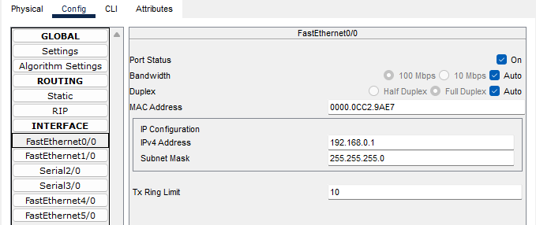

Step 4 : After that open CLI of Router and write these commands one by one by

hitting enter.



Step 5 : Now open IP Config of PC & Laptop by double clicking on PC & Laptop

Icon select the DHCP option then you can see PC or Laptop requesting

IP from DHCP server and show the allotted IP Address.

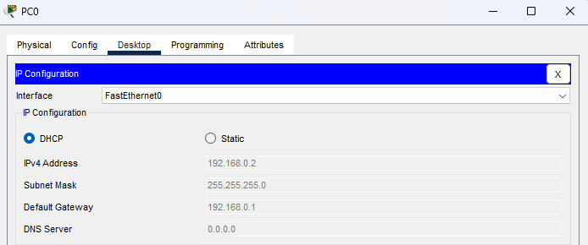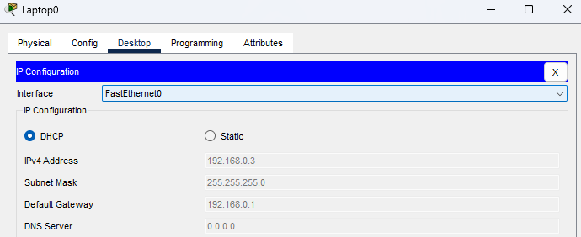

* Diagram:

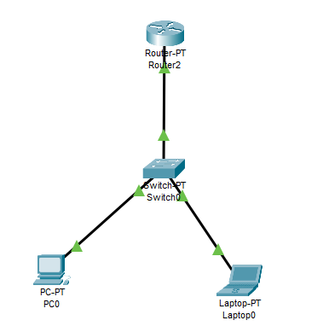

* Output’s:

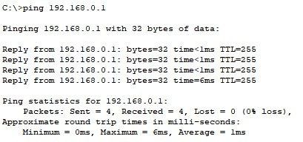

Response coming from Router when ping Router IP in CMD, So DHCP connection I successful.